Dear EE354L students,
Our homework assignments’ philosophy:
==
EE354L is a design course. One needs to try to design to learn design.
For many of our homework assignments (starting from HW#3 Verilog homework), we provide solutions along with the assignment.
You need to try to solve each problem by yourself and then look at the solution to correct your work.
Or read the problem, think how you are going to solve it, look at the solution, understand it. Then after a day or so solve the homework by yourself with minimal peaking into the solution.
Copy of the posting on D2L => Contents => Assignments => EE354L Homeworks => EE354L_HW3 Verilog
==
EE354L_HW3 Verilog
Assignment
Please complete this assignment on your tablet (or on paper and scan it into a pdf file) and submit the pdf file on Gradescope.
I gathered Verilog-related exam questions under this HW#3. Solution is given away.
https://ece-classes.usc.edu/ee254/Verilog/Verilog_Exam_Questions_Exercises_only.pdf
https://ece-classes.usc.edu/ee254/Verilog/Verilog_Exam_Questions_Solutions_only.pdf
Two options:
1. You can download Verilog_Exam_Questions_Exercises_only.pdf, complete it and submit it to get 130% on this homework.
As it is a long homework (15 pages long), we are giving you 130% on this homework if you take time to complete this long homework.
2. Or you can go through the Exercise (question by question) one question at a time, mentally solve it, verify with the solution. Approach us if you do not understand any part of it.
Submit a short text file stating the following and stating what percentage of the homework solution you understood. You will get 100% on this homework if you understood at least 80% of the homework.
==
I have read each question in the 15-page Verilog_Exam_Questions_Exercises_only.pdf, solved it mentally, and then looked at its solution in the Verilog_Exam_Questions_Solutions_only.pdf. I have understood ____% (or more) of the homework solution. I will go to office hours if I did not understand any question or its solution.
==
Best
Gandhi Puvvada

1/22/2023 11:40 PM,
Dear EE354L students,
At 9:57 PM today, I release the EE354L_HW1 assignment through Crowdmark. You must have received an email via Crowdmark with a link to submit your work when done.
This semester, we want to use D2L (https://courses.uscden.net/d2l/login) besides the Bb (https://blackboard.usc.edu/). D2L is another LMS (Learning Management System) like the Bb.
We have setup our EE354L course page on D2L also. We will be using a tool called Crowdmark (https://crowdmark.com/) (a grading support tool like the Grade Scope used in EE109L) for the EE354L exams and Homework assignments. Since Crowdmark is linked to D2L (but not the Bb), we need to go through D2L for our exams and homeworks.
Please make sure that you can login to DEN D2L by going to https://courses.uscden.net/d2l/login and clicking on the red rectangle in the middle reading USC NetID Login .
Even though the USC NetID Login works for D2L, it sometimes does not work for the Crowdmark.
So please establish a direct D2L login using your full email address (something like ttrojan@usc.edu) and a password of your choice (see the login page extract below).
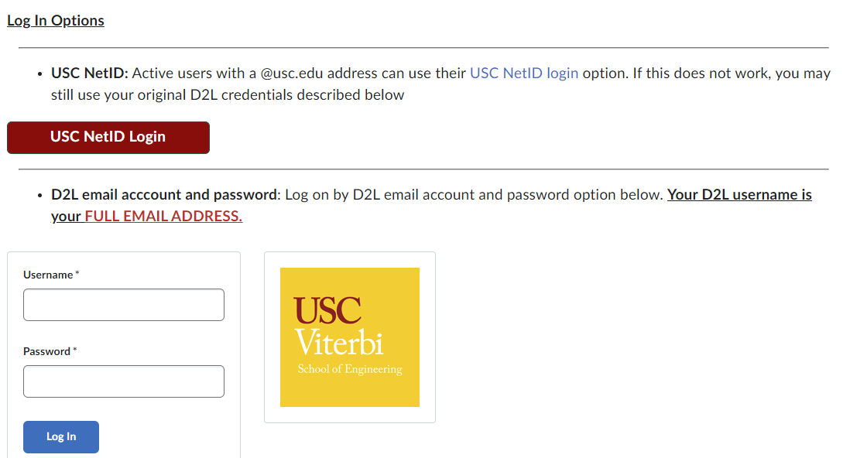
After logging into D2L using your direct login in a browser, in the same browser, please access your crowdmark account at https://app.crowdmark.com/sign-in/usc
Click on the blue rectangle reading Sign in with Brightspace. You should see there your EE354L_HW1 assignment.
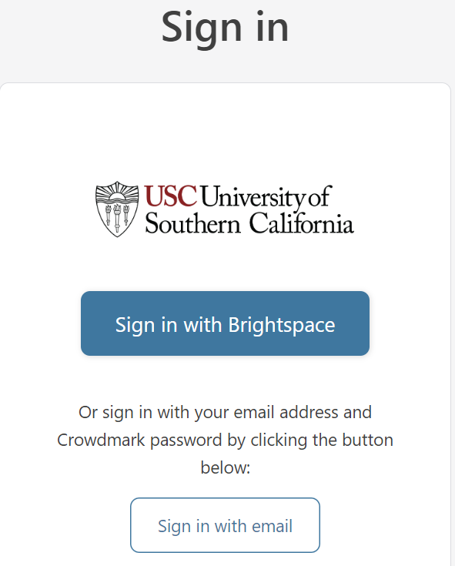
This is where you need to submit your completed HW1 assignment.
Please plan to submit it by 11:30 PM on 1/29/2023 (though the due time is 11:59 PM) as you are submitting it for the first time on Crowdmark and you may face some issues.
This HW#1 is a 14-page assignment. Crowdmark treats it as if it consists of 14 Questions each one page of the assignment. Hence, we labelled the questions Q7P13 (Q7 part on Page 13) and Q7P14 (Q7 part on page 14), etc. You can upload your completed 14-page pdf file into any question. It will separate out into 14 Thumbnails. You then drag the pages between question boxes. Please see
https://crowdmark.com/help/completing-and-submitting-an-assessment/
“Upload your files. Drag and drop your files to the upload areas under the questions or browse to locate them. You can drag pages between questions.”
Thank you for following the procedure.
Gandhi and the rest of the teaching team

