EE201L
Verilog coding assignment – Blocking and Non-Blocking – special counter in Verilog
Synchronous Counter with Jump
This assignment is to help understand these two coding styles.
Recommended Style of Coding: Code the upstream combinational logic (upstream to a register) in the same clocked block as the register is coded.
Coding Style used in Industry: In industry, most engineers are taught thumb rules unfortunately. One of them is this: “Code only bare registers (and FFs) in the clocked block. Use Non-Blocking assignments to code this portion. Do not use Blocking assignments in Clocked blocks. Code all combinational logic in combinational logic blocks using always @ (*) and use blocking assignments only in these blocks”. We, at USC, want you to know the intent of blocking and non-blocking assignments and do not want to be guided by thumb rules made up in industry for use by technicians basically.
The assignment:
A. You are provided with the following design files.
1. Recommended Style of Coding (all files are in completed form):
1.1 ee201L_sync_counter_mix_of_blocking_and_non_blocking.v
1.2 ee201L_sync_counter_mix_of_blocking_and_non_blocking_structured_tb.v
1.3 ee201L_sync_counter_mix_of_blocking_and_non_blocking.do
1.4 ee201L_sync_counter_mix_of_blocking_and_non_blocking_wave.do
1.5 ee201L_sync_counter_results_verilog_Copy_produced_by_desired_coding_style.txt
2. Coding Style used in Industry (all files except 2.1 are in completed form):
2.1 ee201L_sync_counter_separate_combinational_logic.v Complete it
2.2 use the same testbench file 1.2 above
2.3 ee201L_sync_counter_separate_combinational_logic.do
2.4 ee201L_sync_counter_separate_combinational_logic_wave.do
B. Procedure
B.1 Unzip the given .zip file to create a sub-folder called special_counter_with_jump_in_Verilog under Modelsim_projects or Questasim_projects folder. It will contain all the above files. Start a project called, say SC for special counter, and add 1.1 and 1.2 files and simulate using the .do file (1.3 above). This produces ee201L_sync_counter_results_verilog.txt. Compare this file in Notepad++ with the 1.5 file and they should exactly match.
B.2 Go through the design file (1.1 above) and understand it completely. Ask us if you have questions.
Complete 2.1 above to make it functionally equivalent to 1.1. Now remove from your simulation project, the file 1.1 and add in its place your 2.1.
Simulate using the do file 2.3 above and produce ee201L_sync_counter_results_verilog.txt. Compare this file in Notepad++ with the 1.5 file and they should match. If they do not match, see why your design 2.1 is not functionally equivalent to 1.1.
B.3 Go through the waveform produced in your simulation (B.2) above. Play with the waveform controls. See if you change radix to display Control and Clk_cnt as shown below. Check the Radix specified to display the value of the Operation as “LOAD”, etc. Read the testbench and your design file to see how these were produced. Expand the + in front of the Control and Operation and see if you can reconcile the number of bits in these with your code. Your TA will ask questions to see how much you tried to understand.
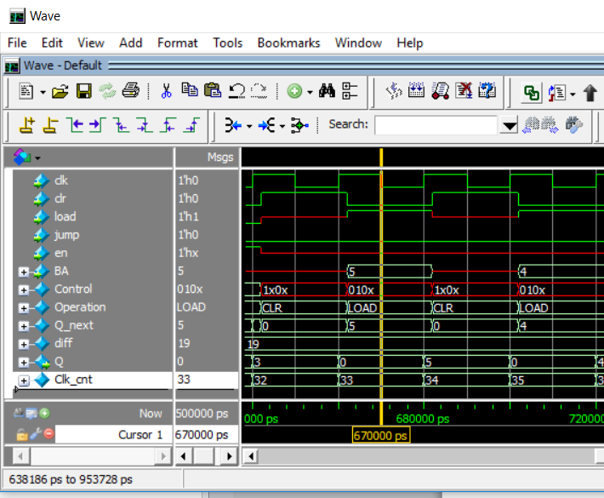
C. Submit the Verilog Design file 2.1 ee201L_sync_counter_separate_combinational_logic.v that you completed together with names.txt as specified by your TA.

